Unit 2

1. What is green Hardware and explain its impacts on environment.[6-7m]

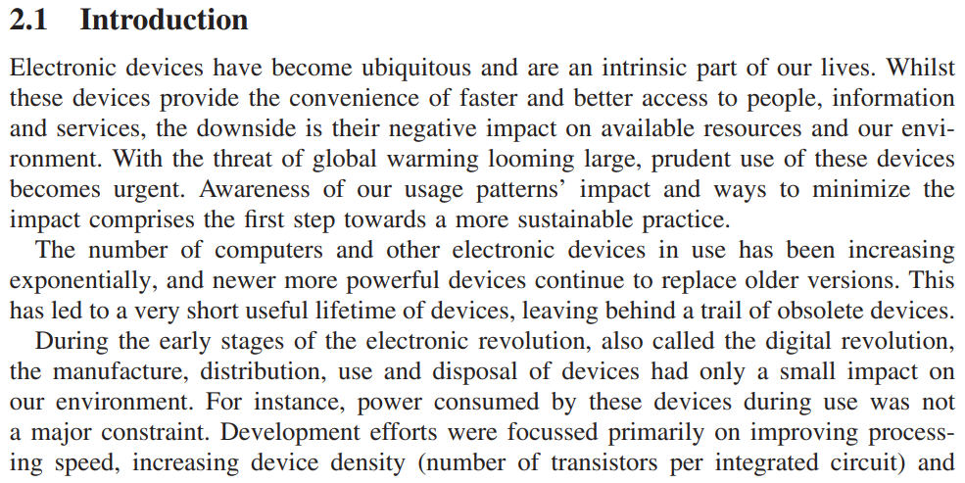

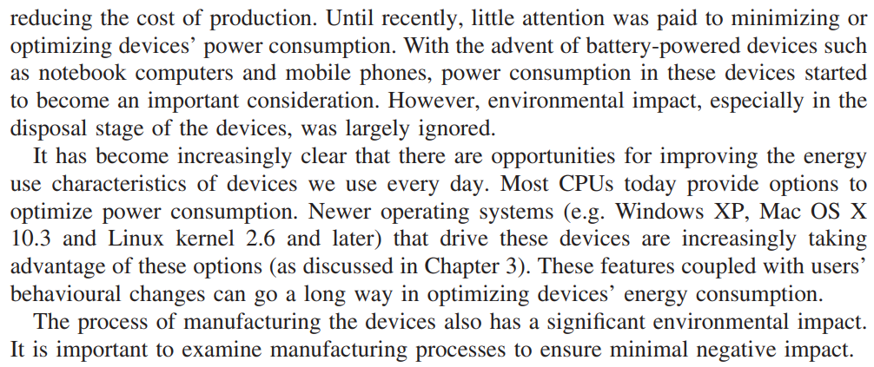
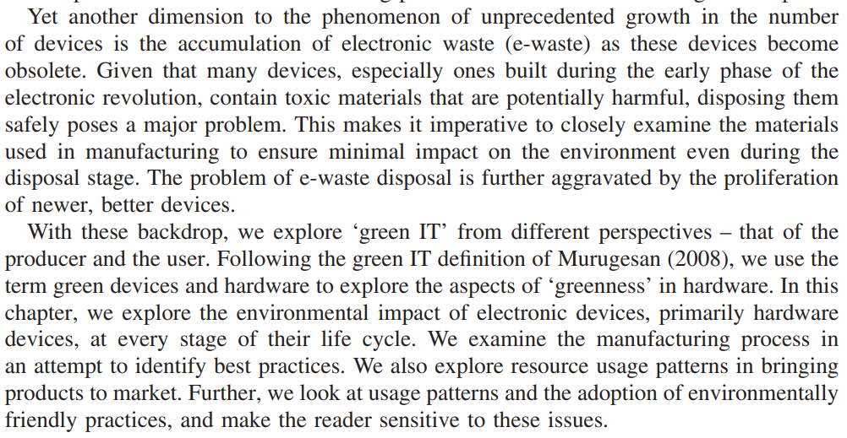

2. Explain briefly life cycle of a device with a diagram.[9-10m]

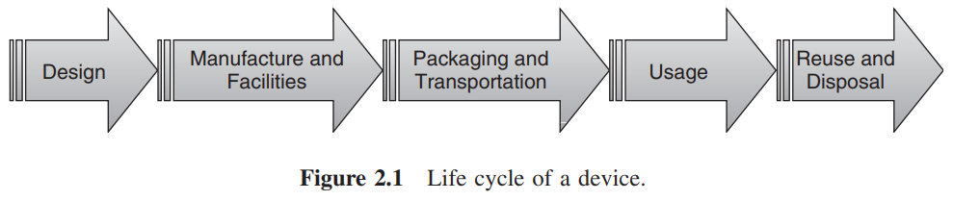

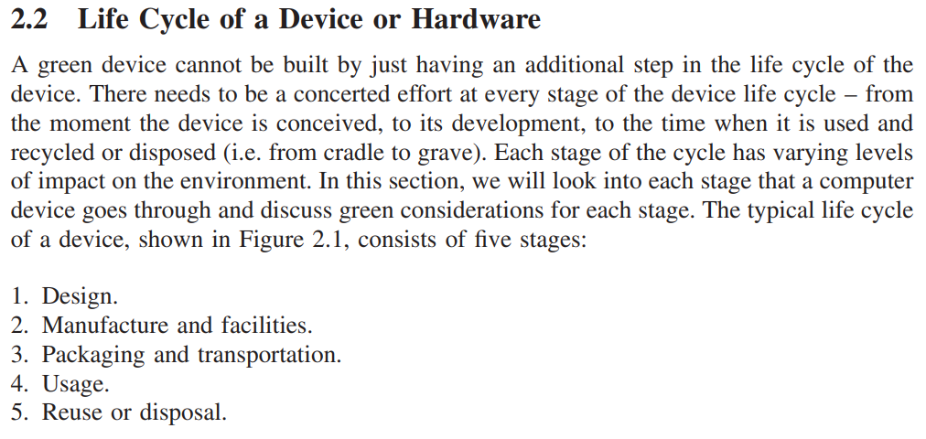

2.2.1 Design In the design stage, the idea is conceptualized and the device is designed, prototyped and tested. Though this stage does not have direct impact on the environment, design stage decisions such as those regarding architecture, constituent components or materials and layout have a huge effect on the environmental impact of other stages. Hence, it is important to design devices so as to keep their environmental impact as low as possible during subsequent stages whilst meeting performance and other requirements. We will look at a possible process improvement that will help design a green device.

3. Differentiate between reuse, recycle and dispose in a device?[7-8m]

4. Define green software and explain how software plays an important role in platform energy efficiency.[6-7m]

5. What is processor power states in given software? Explain its states[7-8m]

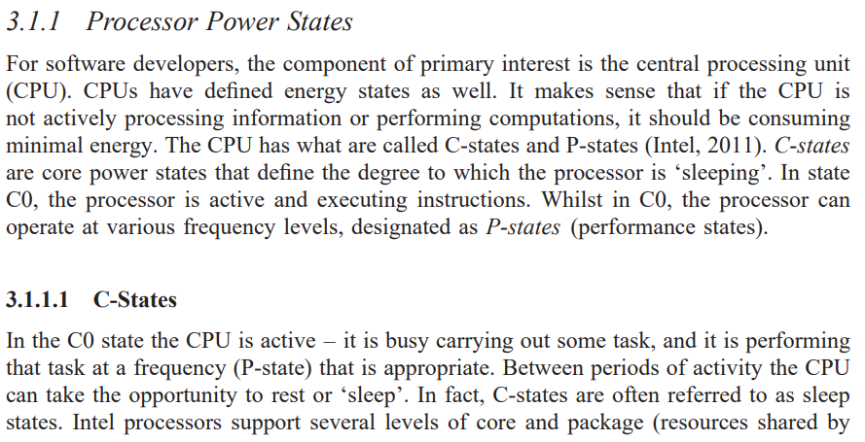

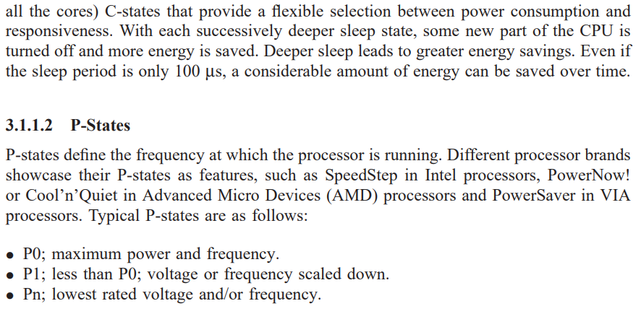

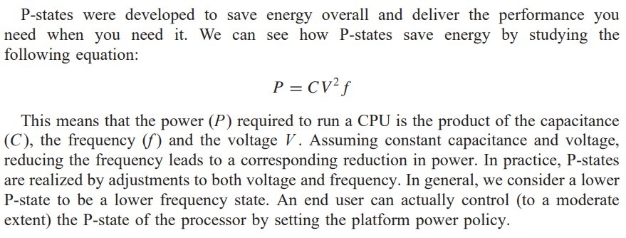

6. With a diagram explain energy saving software techniques [10m].

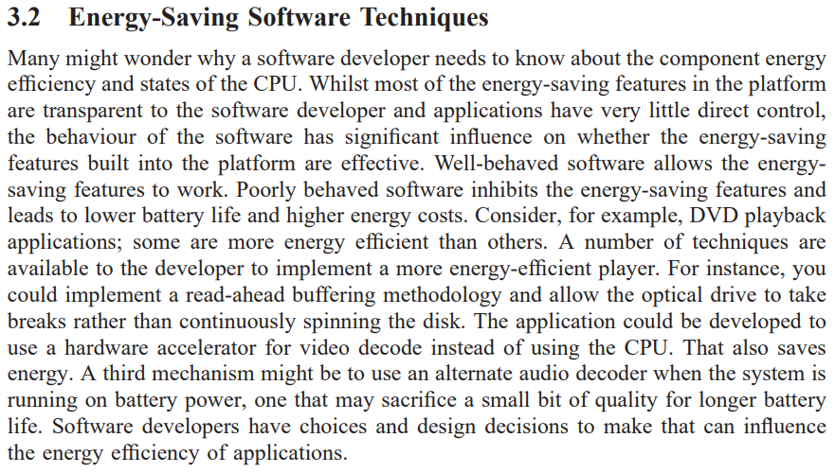

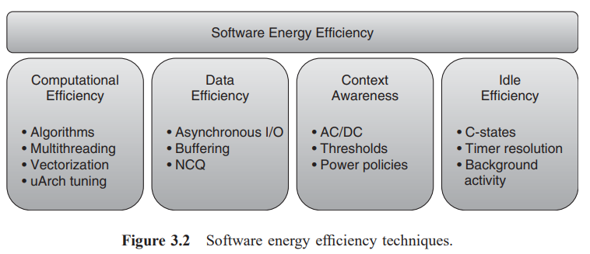

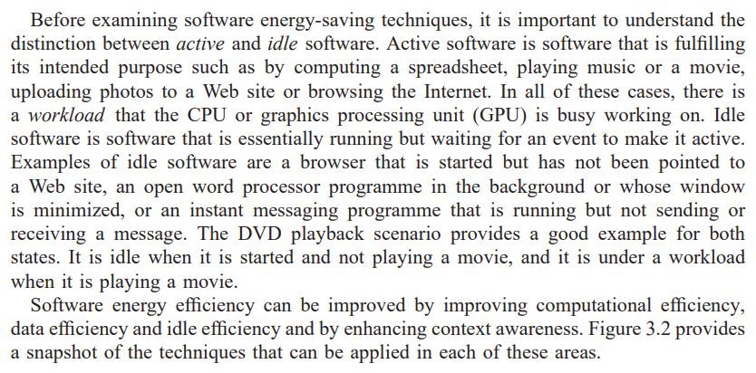

3.2.1 Computational Efficiency Simply put, computational efficiency means getting the workload done quickly, with minimal energy consumption. The amount of effort that computer scientists have put into software performance saves not only time but also energy. We call this the race to idle. The faster we can complete the workload and get the computer back to idle, the more energy we can save. For faster processing, approaches such as efficient algorithms, multithreading, vectorization and uArch tuning are used.

3.2.1.1 Efficient Algorithms

7.Explain software impact on power consumption[7-8m]

